RDF one of the main building blocks of the semantic web technology

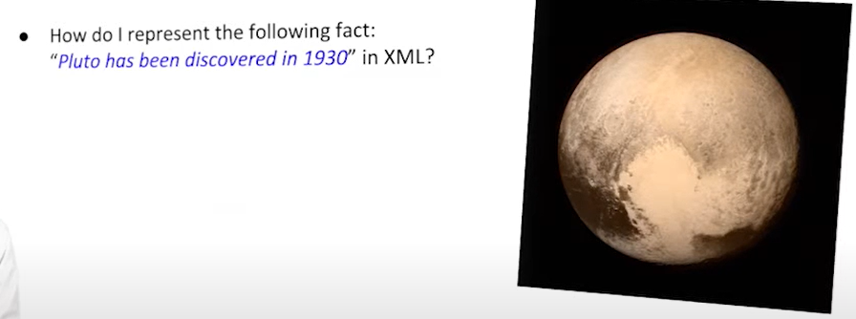

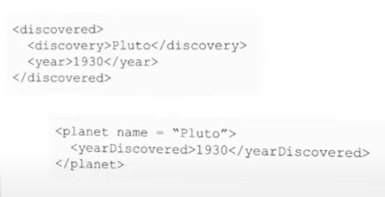

Multiple ways I can represent the fact

But difficult to compare and to understand that they represent the same information

XML can transform information

Can express a subject and predicate with a URI. Object also with URI or literal

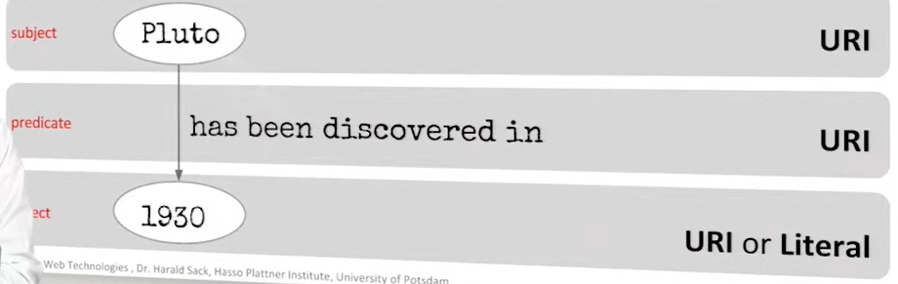

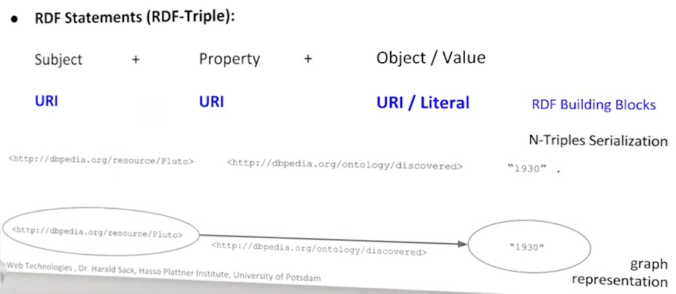

Literal describe data values (not have a separate existence, they are only a value)

blank node: denote existence of an individual with specific attributes, without providing an identification or reference